**DATA QUALITY REPORT FOR NY PROPERTY DATA**

**Description**

**Dataset Name**: Property Valuation and Assessment Data

**Dataset Purpose**: NYC properties assessments to calculate property tax, grant eligible properties, exemptions and/or abatements.

**Data Source**: NYC Open Data

**Time Period**: November 17, 2010

**Number of Fields**: #32

**Number of Records**: 1,070,994

**Summary Table**

**Numeric Fields:**



**Categorical Fields:**



**Data Field Exploration:**

Field 1:

Name: Record

Description: Unique identifier of each entry in the data.

Field 2:

Name: BBLE

Description: Concatenation of borough code, block code and lot.

Field 3:

Name: B

Description: Borough Code

Field 4:

Name: BLOCK

Description: Valid block ranges by borough. Manhattan 1 To 2,255, Bronx 2,260 To 5,958 Brooklyn 1 To 8,955 Queens 1 To 16,350, Staten Island 1 To 8,050.

Field 5:

Name: LOT

Description: Unique number within a borough or block.

Field 6:

Name: EASEMENT

Description: Field that is used to describe easement.

'A' Indicates the portion of the Lot that has an Air Easement.

'B' Indicates Non-Air Rights.

'E' Indicates the portion of the lot that has a Land Easement.

'F' THRU 'M' Are duplicates of 'E'.

'P' Indicates Piers. 'R' Indicates Railroads.

‘U’ Indicates U.S Government

Field 7:

Name: OWNER

Description: Owner’s Name

Field 8:

Name: BLDGCL

Description: Building Class

Field 9:

Name: TAXCLASS

Description: Current Property tax class code.1 = 1-3 Unit Residences, 1a = 1-3 Story Condominiums, 1b = Residential Vacant Land, 1c = 1-3 Unit Condominiums

Originally Tax Class 1, 1d = Select Bungalow Colonies, 2 = Apartments, Tax Class 2a = Apartments With 4-6 Units, 2b = Apartments With 7-10 Units, 2c = Coops/Condos With 2-10 Units, 3 = Utilities (Except Ceiling Rr), 4a = Utilities - Ceiling Railroads, 4 = All Others.

Field 10:

Name: LTFRONT

Description: Lot frontage in feet

Exclude outliers > 370

Data in histogram is 99.45 % populated

Field 11:

Name: LTDEPTH

Description: Lot depth in feet

Exclude outliers > 500

Data in histogram is 99.67 % populated

Field 12:

Name: EXT

Description: Extension. 'V' If the building is irregular shaped, 'E' = Extension,'G' = Garage,'EG' = Extension and Garage.

Field 13:

Name: STORIES

Description: The number of stories for the building.

Exclude outliers > 45

Data in histogram is 99.16 % populated

Field 14:

Name: FULLVAL

Description: Total market value of the land

Exclude outliers > 1009999

Data in histogram is 91.41 % populated

Field 15:

Name: AVLAND

Description: Assessed land value

Exclude outliers > 60000

Data in histogram is 91.61 % populated

Field 16:

Name: AVTOT

Description: Assessed total value

Exclude outliers > 90000

Data in histogram is 84.98 % populated

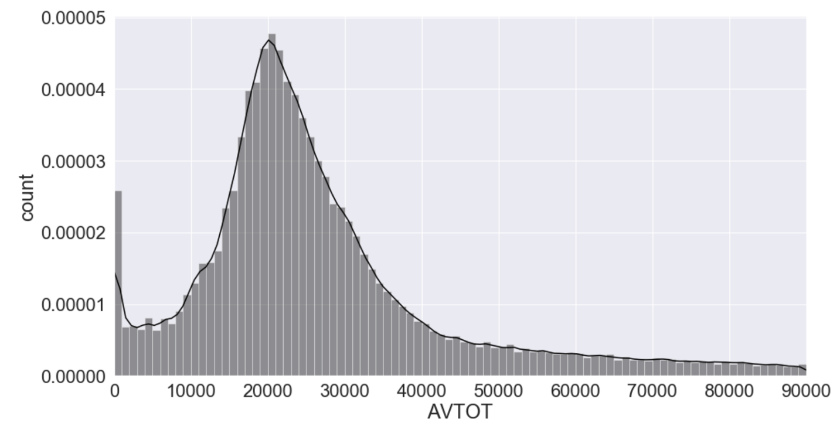

Field 17:

Name: EXLAND

Description: Exempt land value

Exclude outliers > 1005000

Data in histogram is 99.62 % populated

FIELD 18:

Name: EXTOT

Description: Exempt total value

Exclude outliers > 100000

Data in histogram is 96.44 % populated

Field 19:

Name: EXCD1

Description:

Field 20:

Name: STADDR

Description: Street name for the property.

Field 21:

Name: ZIP

Description: Postal zip code of the property

Field 22:

Name: EXMPTCL

Description: Exempt Class used for fully exempt properties only.

Field 23:

Name: BLDFRONT

Description: Building frontage in feet

Exclude outliers > 600

Data in histogram is 97.19 % populated

Field 24:

Name: BLDDEPTH

Description: Lot depth in feet

Exclude outliers > 500

Data in histogram is 97.13 % populated

Field 25:

Name: AVLAND2

Description: New market value of land

Exclude outliers > 105500

Data in histogram is 81.93 % populated

Field 26:

Name: AVTOT2

Description: New total market value

Exclude outliers > 1000000

Data in histogram is 91.61 % populated

Field 27:

Name: EXLAND2

Description: New exempt land value

Exclude outliers > 100000

Data in histogram is 84.00 % populated

Field 28:

Name: EXTOT2

Description: New exempt total value

Exclude outliers > 40000

Data in histogram is 51.75 % populated

Field 29:

Name: EXCD2

Description:

Field 30:

Name: PERIOD

Description: Indicator for the change of period of file. All records have the same value.

Field 31:

Name: YEAR

Description: Year when the data was most recently updated. All records have the same value.

Field 32:

Name: VALTYPE

Description: The parcel’s values are reflected in another lot. All records have the same value.